DAY:1

Practice 1.Accept three numbers from the user using prompt, find the greater of these the numbers and do the sum of that numbers which are greater than 40.

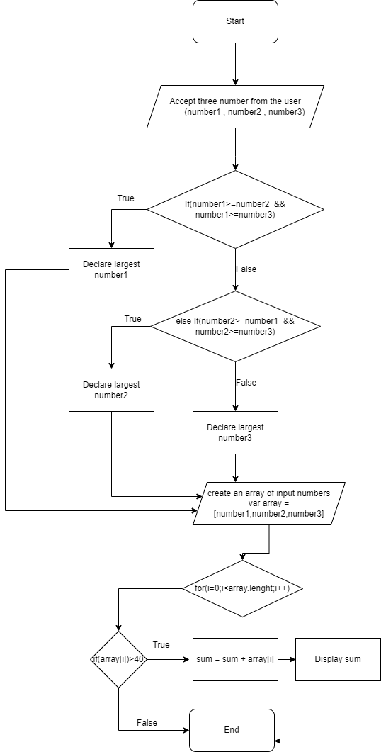

Practice 2:Declare array with 5 city names and iterate these values with the help of loop and display it with alert.

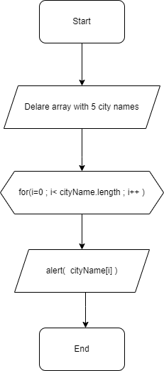

Assignment 1 :